Book

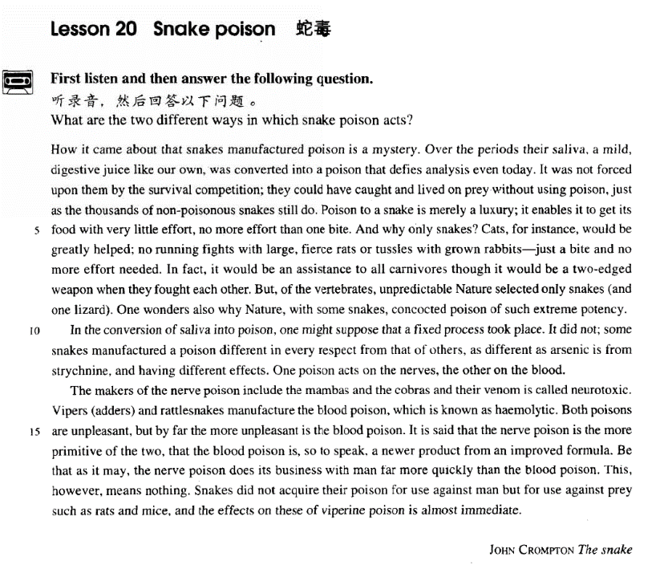

课文

How in came about that snakes manufactured poison is a mystery.

蛇是怎样产生毒液的，这是一个谜。

Over the periods their saliva, a mild, digestive juice like our own, was converted into a poison that defies analysis even today.

蛇的唾液本来和我们人的消化液一样柔和，但经过漫长的时间，演变成了今天仍无法分析清楚的毒液。

It was not forced upon them by the survival competition;

毒液不是生存竞争强加给它们的，

they could have caught and lived on prey without using poison, just as the thousands of non-poisonous snakes still do.

它们也可以不用毒液捕捉动物而生存，就像今天成千上万的无毒蛇那样。

Poison to a snake is merely a luxury;

毒液对毒蛇来说只不过是一种舒适生存的优越手段，

it enables it to get its food with very little effort, no more effort than one bite.

它使蛇不用费多大力气就能捕获到食物，轻咬一口即可。

And why only snakes?

为什么只有蛇才有毒液呢？

Cats, for instance, would be greatly helped;

譬如说，如果猫有毒液，那对猫会大有帮助，

no running fights with large, fierce rats or tussles with grown rabbits -- just a bite and no more effort needed.

它就不必再和又大又凶的老鼠边跑边博斗了，也不必再和大兔子扭斗了，只要咬一口，就不必再费大力气。

In fact, it would be an assistance to all carnivores though it would be a two-edged weapon when they fought each other.

因此，任何食肉动物有了毒液，都能从中获益。不过，当它们相互撕打时，毒液就成了利弊参半的武器，可以杀死对方，也可以被对方的毒液杀死。

But, of the vertebrates unpredictable Nature selected only snakes (and one lizard).

然而，在脊椎动物中，大自然神秘模测地只选择了蛇（还有一种蜥蜴），

One wonders also why Nature, with some snakes concocted poison of such extreme potency.

人们弄不清楚大自然为什么在某些蛇的身上调制出如此高效的毒液来。

In the conversion of saliva into poison, one might suppose that a fixed process took place. It did not;

人们可能认为，唾液转变成毒液，其中有固定的程序。其实没有。

some snakes manufactured a poison different in every respect from that of others, as different as arsenic is from strychnine, and having different effects.

有些蛇产生的毒液也在各方面与另外一些毒蛇产生的毒液不同，就像砒霜不同于马钱子碱一样。不同毒蛇产生的毒液产生的效果不同，

One poison acts on the nerves, the other on the blood.

一种毒液作用于神经，另一种毒液作用于血液。

The makers of the nerve poison include the mambas and the cobras and their venom is called neurotoxic.

产生神经毒液的蛇有一种非洲树眼镜蛇和眼镜蛇，它们的毒液称为神经毒素。

Vipers (adders) and rattlesnakes manufacture the blood poison, which is known as haemolytic.

蝰蛇（蝮蛇）和响尾蛇产生血液毒素，称为溶血性毒液。

Both poisons are unpleasant, but by far the more unpleasant is the blood poison.

这两种毒液都很可怕，但溶血性毒液尤其厉害。

It is said that the nerve poison is the more primitive of the two, that the blood poison is, so to speak, a newer product from an improved formula.

据说，神经毒液在两种毒液中是较为原始的一种，而溶血性毒液，打个比方说，是根据改良配方生产的一种较新的产品。

Be that as it may, the nerve poison does its business with man far more quickly than the blood poison.

不过，神经毒辣液比溶血性毒液在人身上起作用快得多。

This, however, means nothing.

但是，这没有什么关系，

Snakes did not acquire their poison for use against man but for use against prey such as rats and mice, and the effects on these of viperine poison is almost immediate.

因为蛇有毒液不是用来对付人的，而是对付它的猎物，诸如鼠类，毒液对这些猎物会立刻起作用。

词汇讲解

Lesson 20 Snake posion

[daɪ'dʒestɪv] [dɪ'dʒestɪv]

adj. 消化的；助消化的

digestive system / organs / juices / problems

Over the periods their saliva, a mild, digestive juice like our own, was

converted into a poison that defies analysis even today. digest v. 1. 消化

It takes hours for a meal to digest.

I find that I don't digest meat easily.

digest v. 2. to think about sth. so that you fully understand it 理解，领会

He paused, waiting for her to digest the information. digest n. 文摘

Reader’s Digest

Overseas Digest

digestion n. 消化，消化能力；理解，领悟

indigestion n. 消化不良；不能理解，不懂

… if these intimations of a something behind and beyond are not evil humour born of indigestion, or whimsies sent by the devil to mock and madden us …

carnivore

['kɑ:nəvɔ:] ] ['kɑrnə7vɔr]

n. 食肉动物carnivore herbivore

omnivore vegetarian

“carn” = flesh

carnal carnation carnival incarnate incarnation reincarnation “vor” / “vour” = to eat

carnivore carnivorous

herbivore herbivorous

omnivore omnivorous voracious voracity devour vertebrate ['vɜ:təbrɪt]

n. 脊椎动物

vertebrate n. 脊椎动物invertebrate n. 无脊椎动物mammal n. 哺乳动物primate n. 灵长类动物rodent n. 啮齿类动物scavenger n. 食腐动物marsupial n. 有袋类动物crustacean n. 甲壳类动物biped n. 两足动物quadruped n. 四足动物

prey n. 被捕食者，猎物predator n. 捕食者conversion

[kən'və:ʃən] [kən'vɚʒən]

n. 改变，转变；改变信仰

conversion n. 1. when you change sth. from one form, purpose, or system to a different one 改变，转变

the conversion of … into …

the conversion of a barn into a house the conversion of pounds into dollars

In the conversion of saliva into poison, one might suppose that a fixed process took place.

conversion n. 2. when sb. changes from one religion or belief to a different one 改变信仰，皈依

one’s conversion from … to …

his conversion from Christianity to Buddhism Newman's conversion from Anglicanism to Catholicism convert v. 1. 改变（形式或用途）

convert (sth.) to / into sth.

The stocks can be easily converted to cash.

They converted the spare bedroom into an office.

Over the periods their saliva, a mild, digestive juice like our own, was converted into a poison that defies analysis even today.

The pub is a converted warehouse.

The shop was an old converted house with many large, disused fireplaces and tall, narrow chimneys.

a sofa that converts into a bed convert v. 2. 改变信仰convert (sb.) to sth.

European missionaries converted thousands to Christianity. She converted to Catholicism.

convertible adj. 可改变的

a convertible sofa

convertible n. 1. 可兑换证券

In this case, you'd probably construct a portfolio with some shares (but not high risk ones), along with gilts, cash deposits, and perhaps convertibles or the income shares of split capital investment trusts.

Convertible n.2. 敞篷汽车

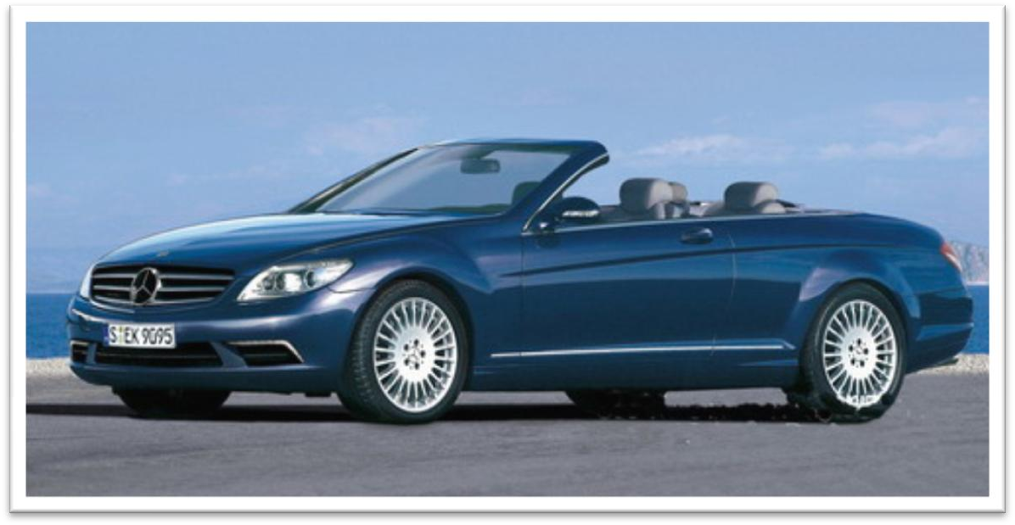

venom ['venəm]

v. 毒液

venom n. a liquid poison that some snakes, insects etc produce when they bite or sting you 毒液

venom → venomous toxin → toxic

poison → poisonous

noxious hazardous lethal deadly

The modern city consists of monstrous edifices and of dark, narrow streets full of petrol fumes and toxic gases, torn by the noise of the taxicabs, lorries and buses, and thronged ceaselessly by great crowds. neurotoxic

[7njuərəu'tɔksik] adj. 毒害神经的

“neur(o)” = “nerv” = nerve 神 经neural neurosis neurotic neurology neurological neurologist

nerve nervous enervate

How it came about that snakes manufactured poison is a mystery. come about: to happen, especially in a way that is not planned Can you tell me how the accident came about?

How did it come about that he knew where we were?

manufacture v. (technical) if your body manufactures a particular useful substance, it produces it（身体）产生，制造，分泌

Vitamins cannot be manufactured by our bodies.

Diabetics don't manufacture enough insulin.

…; some snakes manufacture a poison different in every respect from that of others, …

Vipers (adders) and rattlesnakes manufacture the blood poison, which is known as haemolytic.

How it came about that … is a mystery.

It has never been explained why university students seem to enjoy practical jokes more than anyone else.

How it came about that … is a mystery. It has never been explained why …

It has never been explained why snakes manufactured poison.

造句：谁也无法解释玛雅 (Maya) 文明为什么会突然从地球上消失

(vanish)。

How it came about that Maya civilization vanished from the earth is a mystery.

It has never been explained why Maya civilization vanished from the earth.

Over the periods their saliva, *a mild, digestive juice like our own*, was converted into a poison that defies analysis even today.

defy v. be so difficult as to make (sth.) impossible 无法……

defy description / analysis / belief / solution / explanation / understanding

/ comprehension …

Beauty sometimes defies description. The problem defied solution.

a political move that defies explanation

It's a devastating and barbaric act that defies all comprehension. be more than … can / could...

When my old friend Brian urged me to accept a cigarette, it was more than I could bear.

Dancing proved to be more than the dish could bear, for during the party it capsized and sank in seven feet of water.

The pain is more than I can bear. The story is more than I can believe.

The beauty of the West Lake is more than words can describe.

The weather turned out to be very good, which was more than we could expect.

be beyond sth. 无法……；不容……

The car is beyond repair. The rumor is beyond belief.

The situation is beyond my control.

The results are beyond dispute / controversy. Her beauty is beyond words / description.

His conduct is beyond reproach / criticism. The pain is beyond human endurance.

Working with you is beyond my wildest dreams.

We might say that justice has been done when a man's innocence or guilt has been proved beyond doubt.

It was not forced upon them by the survival competition; they could have

caught and lived on prey without using poison, just *as the thousands of non-poisonous snakes still do*.

force sth. on / upon sb.

It's no good trying to force a diet on someone. people who try to force their own views on you impose sth. on / upon sb.

I don't want them to impose their religious beliefs on / upon my children.

exert sth. on / upon sb.

Much as we may pride ourselves on our good taste, we are no longer free to choose the things we want, for advertising exerts a subtle influence on us.

Antique shops exert a peculiar fascination on a great many people.

…; they *could have caught and lived* on prey without using poison, …

…; they *could have caught and lived* on prey if they had not used

poison, …

Without it we *could* not make a living.

If we *didn’t* have it we *could* not make a living.

Without it, nothing *could* ever be brought to a conclusion; everything

*would* be in a state of chaos.

If we *didn’t* have it nothing *could* ever be brought to a conclusion; everything *would* be in state of chaos.

There *would* be no living things without air.

There *would* be no living things if there *were* no air. In his position, I *would have committed* suicide.

If I *had been* in his position, I *would have committed* suicide.

…; they could have caught and lived on prey without using poison, just as the thousands of non-poisonous snakes still catch and live on prey

without using poison.

Poison to a snake is merely a luxury; it enables it to get its food *with very*

*little effort*, *no more effort than one bite*. luxury necessity

Limousines and perfumes are luxuries while food, clothing, shelter and transportation are daily necessities.

no more than … 仅仅，只不过

When one seriously studies the social orders that have had the opportunity to develop autonomously, the figure becomes no more than an exact and matter-of-fact observation.

Modern cloth diapers are surprisingly easy to use, almost no more work than putting on a disposable.

And why only snakes manufacture poison?

Cats, *for instance*, would be greatly helped; *no running fights with large, fierce rats or tussles with grown rabbits — just a bite and no more effort needed*.

Cats, for instance, would be greatly helped if they manufactured poison. running adj. lasting a long time; continuous 持久的，长时间的

For years he had fought a running battle with the authorities over the

land.

tussle n. a fight using a lot of energy, in which two people get hold of each other and struggle 扭打，搏斗

tussle with …

She had a brief tussle with her conscience before telling the whole story.

In fact, it *would* be an assistance to all carnivores though it *would* be a two-edged weapon when they *fought* each other.

In fact, it would be an assistance to all carnivores if they manufactured poison.

two-edged weapon

As is so often pointed out, knowledge is a two-edged weapon which can be used equally for good or evil.

two-edged weapon / sword

double-edged weapon / sword

… though it *would* be a two-edged weapon if they *fought* each other. How can I explain it to you when you won’t listen?

When I reverse the car, it makes a funny noise. fight (with) sb.

Two guys were fighting (with) each other in the street.

But, of the vertebrates, unpredictable Nature selected only snakes *(and one lizard)*.

of prep. used when comparing related things （用于比较时）在……中

I'm surprised that you of all people think that. A flat tyre today of all days what bad luck!

He's the best looking of the three brothers.

One wonders also why Nature, *with some snakes*, concocted poison of such extreme potency.

concoct v. to produce sth. unusual by mixing things in a new way, esp. a drink or meal 调制

The soup was concocted from up to a dozen different kinds of fish.

potency n. the strength of sth., esp. a drug, on your mind or body 效力

Improper storage may decrease the potency of the drug.

In the conversion of saliva into poison, one might suppose that a fixed

process took place.

In the organization of industrial life the influence of the factory upon the physiological and mental state of the workers has been completely neglected.

the conversion of … into …

the conversion of a barn into a house the conversion of pounds into dollars

In the conversion of saliva into poison, one might suppose that a fixed process took place.

take place v. sth. happens that is planned or arranged（计划之中的事情）

发生

Where is the meeting taking place?

The wedding will take place at St. Andrew's church.

It did not; some snakes manufacture a poison different in every respect from that of others, as different as arsenic is from strychnine, and having different effects.

be different from …

in every respect / aspect / way

His function is analogous to that of a judge, … as different as … is from …

造句：中国文化在各个方面都与美国文化不同，就像大熊猫与白头鹰

(bald eagle) 不同一样。

Chinese culture is different in every respect from that of America, as different as the giant panda is from the bald eagle.

One poison acts on the nerves, the other on the blood. act v. to have an effect or use 有某种效果或作用 act on …

Alcohol acts on the brain.

Disinfectants act on bacteria in two main ways. act as …

Later it was found that there was a type of mosquito which acted as the carrier of this disease and passed it on to the rabbits.

One poison acts on the nerves, the other (acting) on the blood.

The makers of the nerve poison include the mambas and the cobras and

their venom is called neurotoxic.

Vipers (adders) and rattlesnakes manufacture the blood poison, which is known as haemolytic.

be called …

be known as …

be referred to as … be addressed as …

… and their venom is called neurotoxic.

The terrible secret is called 'a skeleton in the cupboard '. Because of this, they were known as 'prize-fighters'.

People who work in offices are frequently referred to as 'white collar workers' for the simple reason that they usually wear a collar and tie to go to work.

The president should be addressed as 'Mr. President'.

by far (used with comparative or superlative adjectives or adverbs) by a great amount ……得多

The last of these reasons is by far the most important.

The second half of his voyage was by far the more dangerous part, during which he sailed round the treacherous Cape Horn

Both … are …, but by far the more … is …

Both books are interesting, but by far the more interesting is ‘*Harry Potter’*.

It is said that the nerve poison is the more primitive of the two, that the

blood poison is*, so to speak,* a newer product from an improved formula. so to speak 好像，仿佛，可谓是，可以说是

He is, so to speak, a walking dictionary.

The Han nationality and the minority nationalities are all, so to speak, members of the same family.

as it were = so to speak

He is, as it were, a walking dictionary.

The Han nationality and the minority nationalities are all, as it were, members of the same family.

They will be able, as it were, to see and hear us in action.

They can never, as it were, lead independent lives, or 'rule the world' by making decisions of their own.

He gets the solid shape, as it were, inside his head—he thinks of it, whatever its size, as if he were holding it completely enclosed in the hollow of his hand.

Reading is thought to be a kind of conversation between the reader and the text. The reader puts questions, as it were, to the text and gets answers. In the light of these he puts further questions, and so on.

formula n. a list of the substances used to make a medicine, fuel, drink etc, showing the amounts of each substance that should be used 配方，处方Our products are handmade from traditional formulas.

The formulas for the drinks are closely guarded secrets.

Be that as it may, the nerve poison does its business with man *far more quickly than the blood poison*.

Be that as it may = However that may be = Despite that

Be that as it may, our expenditure is bound to increase. “I’m tired.” “Be that as it may, you have to do some work.” Come what may = Whatever may happen

Come what may, we'll always stand by your side. Come wind or rain = whether wind or rain comes Come wind or rain, I will go.

do business with …

I was fascinated by the different people who did business with me. mean nothing: be not important 不重要

Time meant nothing to me while I was travelling.

Snakes did not acquire their poison *for use against man* but *for use against prey such as rats and mice*, and the effects on these of viperine

poison is almost immediate.

the effect / influence / impact of … on / upon …

In the organization of industrial life the influence of the factory upon the physiological and mental state of the workers has been completely neglected.

… and the effects on these *of viperine poison* is almost immediate.